EXPERIMENT
AIM : Design an automatic night lighting system (with 4 connected led’s) such the system is only activated when the master control switch is pressed. a) Below 50% value of full brightness all LED’s constantly ON. b) Above 50% value of full brightness only first LED is ON

Apparatus: Arduino,LDR,LED,Resistor(10k,220),wires,beardboard

Circuit Diagram
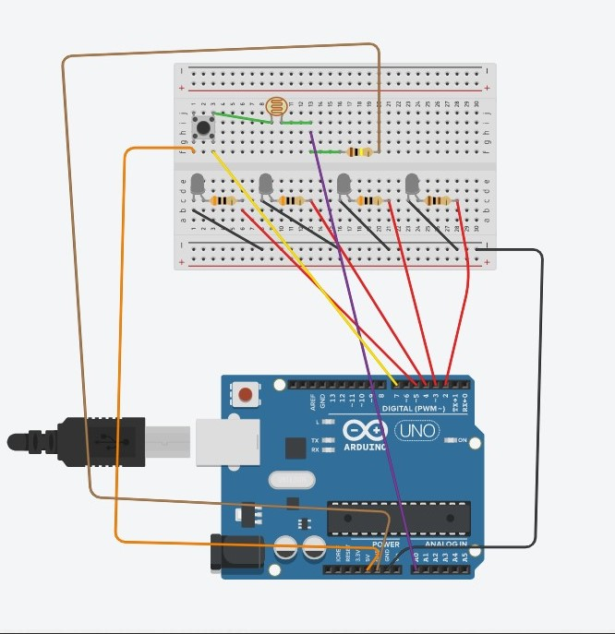
Program

​int c = 2;
void setup()
{
Serial.begin(9600);
pinMode(7,INPUT);
pinMode(2,OUTPUT);
pinMode(3,OUTPUT);
pinMode(4,OUTPUT);
pinMode(5,OUTPUT);
}

void loop() {
int a =analogRead(A0);
int b =digitalRead(7);
Serial.println(a);
if (b ==HIGH)
{
c++;

}
if ( (c % 2) == 0)
{
digitalWrite(2,LOW);
digitalWrite(3,LOW);
digitalWrite(4,LOW);
digitalWrite(5,LOW);
}

else
{
if(a<1014)

{
digitalWrite(2,HIGH);
digitalWrite(3,HIGH);
digitalWrite(4,HIGH);
digitalWrite(5,HIGH);
}
else
{
digitalWrite(2,HIGH);
digitalWrite(3,LOW);
digitalWrite(4,LOW);
digitalWrite(5,LOW);
}
}

}

RESULT
Automatic night lamp functioning was verified after uploading the program

